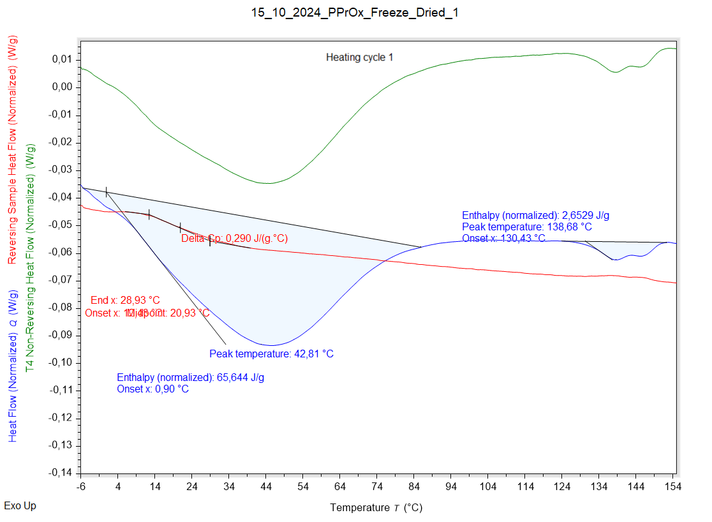

|  |  |  |  |
| --- | --- | --- | --- |
| Solvent evaporation | Solvent evaporation onset (°C) | Solvent evaporation peak (°C) | Solvent evaporation enthalpy (J/g) |
|  | 0,900 °C | 42,807 °C | 65,644 J/g |

|  |  |  |  |
| --- | --- | --- | --- |
| Melting | Melting onset (°C) | Melting peak (°C) | Melting enthalpy (J/g) |
|  | 130,433 °C | 138,677 °C | 2,6529 J/g |

|  |  |  |  |
| --- | --- | --- | --- |
| Glass transition | Glass transition onset (°C) | Glass transition endpoint (°C) | Glass transition midpoint (°C) |
|  | 12,476 °C | 28,927 °C | 20,931 °C |

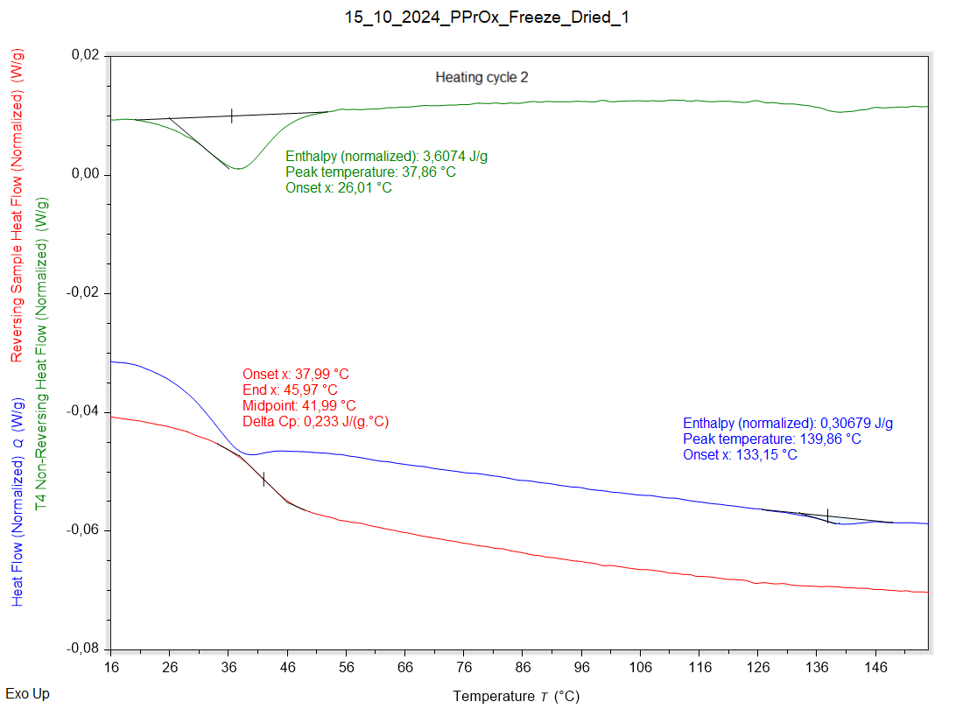

|  |  |  |  |
| --- | --- | --- | --- |
| Solvent evaporation | Solvent evaporation onset (°C) | Solvent evaporation peak (°C) | Solvent evaporation enthalpy (J/g) |
|  | 26,013 °C | 37,862 °C | 3,6074 J/g |

|  |  |  |  |
| --- | --- | --- | --- |
| Melting | Melting onset (°C) | Melting peak (°C) | Melting enthalpy (J/g) |
|  | 133,153 °C | 139,864 °C | 0,30679 J/g |

|  |  |  |  |
| --- | --- | --- | --- |
| Glass transition | Glass transition onset (°C) | Glass transition endpoint (°C) | Glass transition midpoint (°C) |
|  | 37,995 °C | 45,967 °C | 41,990 °C |